**tuNtw;Gf; FO Cf;Ftpg;G gapw;rp**

**mwpf;if**

jpfjp – 26.04.2024

Neuk; - 2.30pm to 4.45pm

,lk; - khatD}u; nghJ Nehf;F kz;lgk;.

gq;F gw;Wdu;fs; - IR (ngz; - 08)

IDP (ngz; - 05)

gzpahsu;fs; - 02

nkhj;jk; - 15

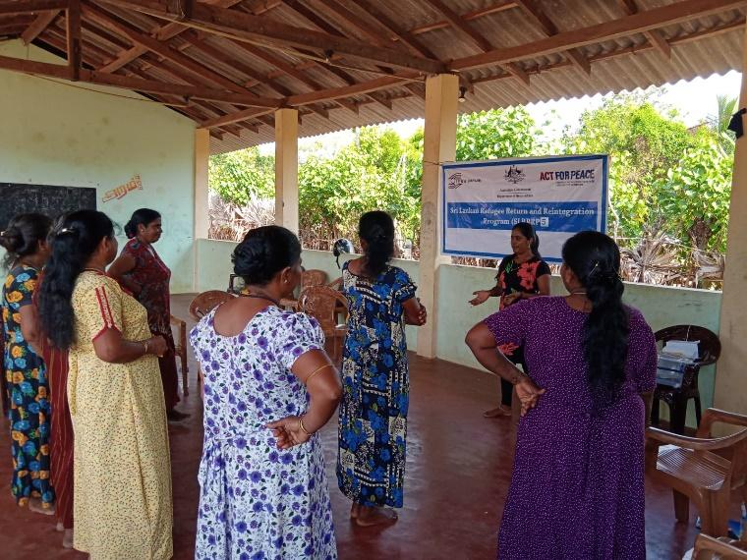 ,f; fye;JiuahlyhdJ 26.04.2024 khatD}u; nghJNehf;F kz;lgj;jpy; tsthyu; m[e;jpdp mtu;fs; jiyikapy; ,lk;ngw;wJ. ,jpy; tuNtw;Gf;FO cWg;gpdu;fs; kw;Wk; mz;ikapy; ehL jpUk;gpatu;fs; fye;J nfhz;lhu;fs;. tuNtw;Gf; FOf;fspd; cWg;gpdu;fspd; mwpT jpwd;fis tpUj;jp nra;Ak; Nehf;fpy; Nkw;nfhs;sg;gl;l Cf;Ftpg;G gapw;rpapy; Kjyhtjhf mwpKfk; ,lk;ngw;wJ. midtUk; jk;ik mwpKfk; nra;J nfhz;lhu;fs;.

Kjy; nraw;ghlhf tuNtw;G FO vd;why; vd;gJ njhlu;ghfTk; mJ cUthf;fg;gl;ljd; Nehf;fk; vd;gd nhjlu;ghfTk; gq;Fg;gw;Wdu;fSf;F njspTg;gLj;j gl;lJ.

gpd;du; mLj;j nraw;ghlhf jz;lthsghij nraw;ghL ,lk; ngw;wJ. mjpy; xU ehL jpUk;Gk; egUf;F Muk;gj;jpy; ,Ue;J ,Wjp tiu vd;ndd;d Njitg;ghLfs; cs;sJ vd;Wk; mj; Njitia vt;thW ahuplk; nfhz;L nry;y Ntz;Lk; vd;gJ njhlu;ghfTk; ,r; nraw;ghL %yk; cWg;gpdu;ffSf;F njspTg;gLj;jg;gl;lJld; ,dp tUfpd;w egu;fSf;F ,j; jfty;fs; gupkhwg;gl Ntz;Lk; vdTk; $wg;gl;lJ.

gpd;du; ehL jpUk;gp xU ey;y epiyapy; cs;s xU FLk;gj;jpd; rk;gtfw;if xd;wpid gq;Fgw;Weu;fSld; gfpu;e;J nfhz;L njspTgLj;jpdhu;.

gpd;du; tuNtw;Gf;FO cWg;gpdu;fis ,U FOf;fshf gpupj;J xU FOtpdu; ehL jpUk;gpatu;fshfTk; kw;iwa FOtpdu; mtu;fSf;F ghjpg;Gf;fis Vw;gLj;Jgtu;fshfTk; $wg;gl;L ghjpg;Gf;fis Vw;gLj;Jgtu;fs; gY}id cilf;f Ntz;Lk;. ehL jpUk;gpatu;fs; gY}id ghJfhf;f Ntz;Lk; vd $wg;gl;L tpisahl;L ,lk;ngw;wJ. mjd; %ykhf ,e;jpahtpy; ehL jpUk;gpa xUtiu ,t;thwhd ghjpg;Gf;fspy; ,Ue;J vt;thW ghJfhg;gJ vd;gJ njhlu;ghf njspTgLj;jg;gl;lJ.

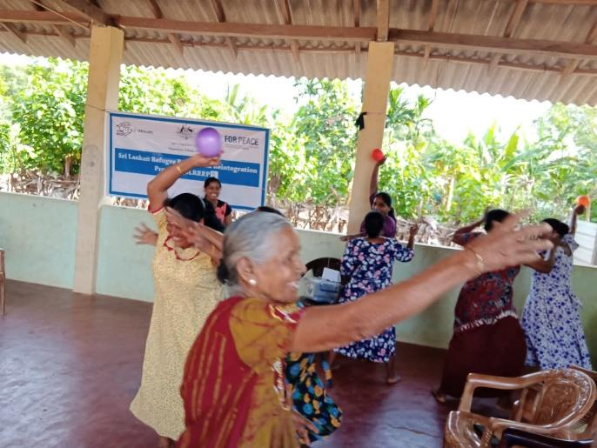gpd;du; mjpfhu eil vDk; gapw;rp ,lk;ngw;wJ. mjpy; xt;nthUtUf;Fk; xt;nthU epiyfs; toq;fg;gl;lL mjhtJ MSeu;>fpuhk mYtyu;>gpuNjr nrayhsu;> Kjpatu;> ngz; jiyik jhq;Fk; FLk;gk;>mikr;ru; vd gy;NtW epiyfs; xt;nthUtUf;Fk; toq;fg;gl;L thrpf;fgLk; Nfs;tpfSf;F mt; epiy nghUj;jkhf ,Ue;jhy; xU mb efu;e;J nry;y Ntz;Lk; vd $wg;gl;lJ.

mjd;gb efu;e;J nrd;w tpjj;jpy; mjpfhuk; cs;stu;fs; Kd; ,lj;jpYk; eypTw;wtu;fs; gpd; epiyapYk; ,Ug;gjw;fhd fhuzq;fis tpsf;fp mJ njhlu;ghf njspTg;gLj;jpaik.

njhlu;e;J ehL jpUk;gpa kf;fs; trpf;Fk; gFjpapy; mtu;fSf;F jw;fhyj;jpy; cs;s gpur;ridfs; njhlu;ghf fye;Jiuahb kuk; xd;wpid jahu; nra;J mjpy; mtu;fSf;F cs;s gpur;ridfs;> gpur;ridf;fhd fhuzq;fs; vd;d mt;thwhd gpur;ridfis vt;thW jPu;j;Jf; nfhs;tJ Nghd;w tplaq;fs; fye;Jiuahlg;gl;L fhl;rpg;gLj;jg;gl;lJ.

gpd;du; ngz;fs;> rpWtu;fs; njhlu;ghd gpur;ridfSf;F mwptpf;f Ntd;ba njhiyNgrp ,yf;fq;fs; gupkhwg;gl;L r%fj;jpy; ,t;thwhd gpur;ridfs; ,Ug;gpd; mjid gag;glhky; mwptpf;fg;gl Ntz;Lk; vdTk; $wpaNjhL NkYk; md;whlk; Njitg;gLfpd;w mtru Nehahsu; fhT tz;b ,yf;fk;> jP mizg;G Jiw ,yf;fk;> mtru fhtw;Jiw miog;G ,yf;fk; vd;gd mjpy; fhl;rpg;gLj;jg;gl;lJ.

gpd;du; gq;Fgw;Wdu;fspd; mDgtf; fUj;Jf;fSld; ,f; fye;Jiuahly; ,dpNj epiwTg; ngw;wJ. rpy fUj;Jf;fs; gpd;tUkhW

* 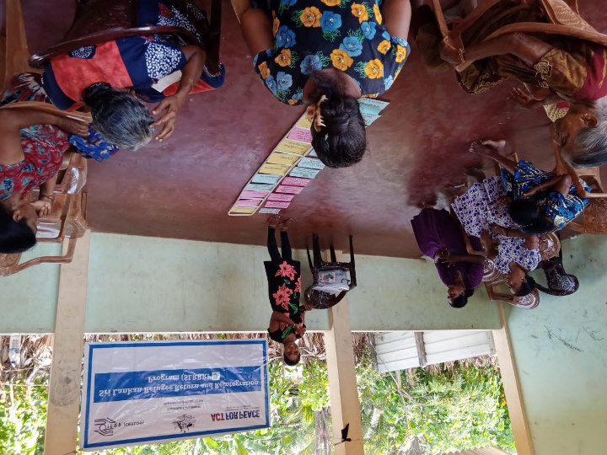tuNtw;GFO njhlu;ghd xU KOikahd tpsf;fk; fpilf;fg;ngw;wjhf $wpdhu;fs;.
* rpy Ngu; jq;fSf;F mtru miog;G ,yf;fq;fs; njhlu;ghf fijj;jJ gpupNahrdkhf ,Ue;jjhf $wpdhu;fs;
* Mtzj;NjitfSf;F vt;thW ahuplk; nry;y Ntz;Lk; vd;gJ njhlu;ghf njupe;J nfhz;ljhf $wpdhu;fs;.

njhFg;G

f. m[e;jpdp